Applied Statistical Modelling Analysis of E-commerce Performance and Customer Spending

Table of Contents
Introduction 3
Key Business Questions and Setup of Hypotheses 4
Data Pre-processing, Data Cleaning, and Feature Engineering 4
Exploratory Data Analysis (EDA) 6
Transactional and Geographic Summaries 6
Temporal Trends and Product Performance 6
Sampling Methodology and Data Transformation 7
Model Selection and Validation of Assumptions 8
Application of Inferential Statistics 9
To measure Effect Size and Robustness: 9
Interpretation of Model Outputs and Business Translation 9
OUTPUT ANALYSIS (GRAPHS & CHARTS) 10
Conclusion & Limitations of Analysis 15
In what ways is it that different? 15
References 17

Introduction
In the fiercely competitive Ecommerce market, grasping the buying habits and preferences of audiences across borders is a top priority for fine-tuning pricing tactics, regional marketing, logistics, and more. This data is transnational transactional data from an online non-store retailer based in the UK, taken from the given file "Online Retail.xlsx". Their niche is unique and all occasion gifts and a significant number of their client base are wholesalers and B2B customers.
The main challenge of this report is segmenting the markets and calculating customer lifetime value of various geographic segments. The retailer has its headquarters in the United Kingdom, which naturally means that its domestic market makes up the bulk of its transactions. International markets, where Germany is home to one of its major European target markets, however, demand a high level of investment in shipping, customs and customer services, including repatriation services. Before these operational costs can be justified management must be confident that the average spend of an international customer (Germany) in a large market is significantly different to that of a UK customer. Statistically, if international buyers spend on average more, the business makes sense in investing more in Customers Acquisition Cost (CAC) in those areas.
On the other hand, when the spending profiles are the same or significantly reduced, strategy should be followed to reconsider aggressive expansion into foreign markets. Key Business Questions and Seeking answer to them.

Key Business Questions and Setup of Hypotheses
To answer these questions and give targeted data-driven recommendations this report focuses on the following key business questions:
- What is the distribution of transactional income across the business in total?
- Which are the company's most profitable foreign markets beyond the UK?
- What impact do monthly cyclicality data have on transaction volume and gross revenue?
- What are the specific Sales Items (Stock Codes) that generate the highest revenue?
- Most importantly, is there a significant difference between the mean total expenditure of customers in the United Kingdom compared to Germany?
To definitively answer the final question regarding customer spending behaviour, we formalize the following statistical hypotheses for our inferential testing:
Null Hypothesis (H0): There is no significant difference in the mean log-transformed customer spending between the United Kingdom and Germany. (u_{UK} = u_{Germany})(Emmert-Streib, 2024).
Alternative Hypothesis (H1): There is a statistically significant difference in the mean log-transformed customer spending between the United Kingdom and Germany. (u_{UK} neq u_{Germany})(Aven, 2023)

Data Pre-processing, Data Cleaning, and Feature Engineering
A statistical model is very sensitive to noise and error in the data, which is a reason for data pre-processing, data cleaning, and feature engineering. Hence, careful data preparation was done considering the packages of R, dplyr, lubridate and ggplot2. The raw dataset was taken in and checked for missing data and duplicate rows. As soon as I started to load the data it was clear that some of the categorical variables in the data would require explicit categorical data type conversion so that R don't treat them as numerical variables(Zhang et al., 2023) (Bailey et al., 2023):
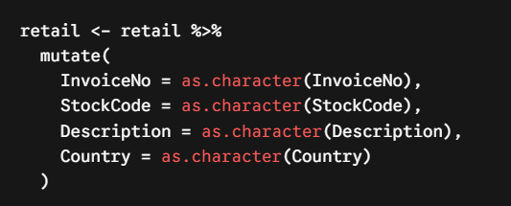
The most important stage in the pre-processing pipeline was to remove bad transactions. Certain orders in this retail data set are cancelled, and they start with the letter "C". Also, a small number of records had negative quantities and/or unit prices which were left either because there were system errors, or because a bad debt adjustment was being applied. Lastly, transactions that were missing a CustomerID were excluded, since our main analysis is based on data being grouped by customer:
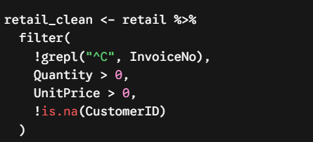
After removing the data points with extreme outliers, a new variable, Revenue was introduced into the dataset by multiplying the quantity of items bought with the unit price of the items, for each item on a row.
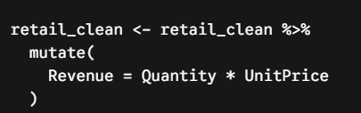
Given that the business question is related to customer behaviour and not transactions, the data then had to be aggregated to the customer level. We aggregated by CustomerID and Country to determine the total lifetime spend (CustomerSpend), number of transactions and total items purchased per unique buyer.

Exploratory Data Analysis (EDA)
Exploratory Data Analysis (EDA) is a tool that helps us to appreciate the overall economic condition of the business before utilizing any of the more rigorous inferential tests (Katyal, Sharma and Kannan, 2025).

Transactional and Geographic Summaries
Our initial descriptive information for the transactional revenue indicates that it follows a highly skewed distribution. The resulting histogram (using 100 bins) and boxplot clearly showed that most of the individual transactions occurred at very low amounts of money, with some very high outlier amounts of money. Whole sale B2B transactions are common where the max values are way out of line relative to the median value (Alabi and Bukola, 2023) (Samara et al., 2022).
A geographical aggregation was conducted:
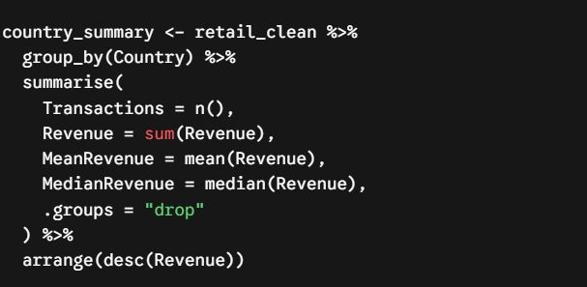

The United Kingdom accounts for the vast majority of transaction volume and total revenues, this code said. The top_countries using slice_head(n = 10) did, however, reveal that Germany is one of the best secondary markets, and closely followed by France and EIRE.

Temporal Trends and Product Performance
To measure the cyclicality of a business, the InvoiceDate was converted to a monthly lower level using the lubridate package. A time-series analysis (using geom_line) showed that the monthly revenue and number of transactions for the company were trending over time. In a retail type of data set of this character, there are generally large increases in Q4 (December to February), which correspond to the shopping season.
Furthermore, a product level drilldown was produced to determine which Product StockCode / Description combinations are generating the highest top line revenue, thus offering the supply chain team with clear indications on where to prioritise their inventory.

Sampling Methodology and Data Transformation
In order to investigate the main hypothesis, the dataset was reduced to only include customers from the United Kingdom and Germany:
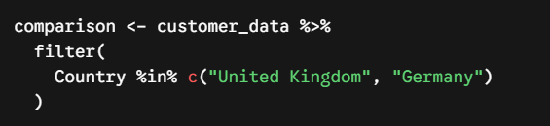
One of the main problems in this dataset is the extremely skewed distribution of classes, i.e. the number of customers in the UK is significantly greater than the number in Germany. Because the quantity of UK data was very large, a stratified random sample was taken so as to not swamp our statistical tests. We used the same set of seeds for reproducibility and took 50% of each population from each country:
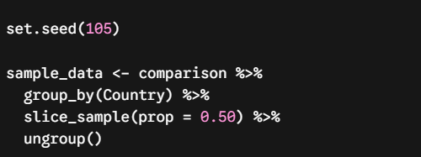
Monetary data associated with e-commerce is difficult to conform to normality assumption of many of the parametric statistical tests, as it is highly skewed to the left. A log transformation was performed on the CustomerSpend variable to address this issue. In particular, the log1p function was used to ensure that any zeros were not treated as NaN and the results could be safely added to 1 so as not to return infinite numbers (Narra et al., 2025).
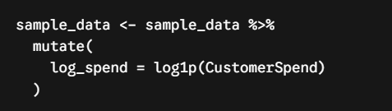
When plotting the normalized data in a grouped boxplot (geom_boxplot(aes(x = Country, y = log_spend)), the comparisons were much easier to visualize, and the distribution of the data was much more normalized so that the central tendency in each market was easily visible.

Model Selection and Validation of Assumptions
If we are interested in testing our hypothesis about differences in the average amount of money that customers spend, then a two-sample hypothesis test is needed. The two-sample t-test was chosen to be an optimal inferential model.
Welch's t-test does not make the assumption of equal variances (homoscedasticity) for the two populations, as with the regular Student's t-test. Volatility of the regions' spending is almost always different in complex business environments (de Winter, 2026).
Prior to conducting the test, we carefully tested the assumptions under which we work with statistics.
Independence: The observations are independent of one another. The samples in this data set are independent of each other, with each row being one person's total CustomerID spend – one people spend isn't mathematically influencing another.
Normality checks for log-transformed spending data: We checked the normality of the two spending distributions (log-transformed) using a Q-Q plot and Shapiro-Wilk test (shapiro.test). The large sample sizes made it difficult to get a sense of how close the data were to perfect normality, but the Q-Q plots showed that the log_spend distributions were close enough to being normal to not notice it. This allows for minor deviation here because of the Central Limit Theorem and the strength of the t-test (Jiang, Li and Zhang, 2024).
In order to definitively test whether or not the variances were equal, Levene's Test was applied on the car package:
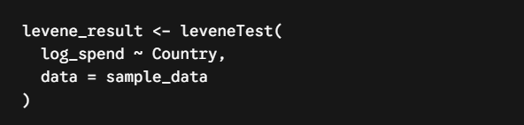
The outcome of the Levene's test led us to choose the False value for our next t-test (var.equal), justifying the use of the Welch adaptation.

Application of Inferential Statistics
The primary hypothesis was tested with the help of welch's t-test after the assumptions were validated and the data was transformed (Casella and Berger, n.d.).
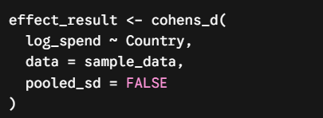

To measure Effect Size and Robustness:
A business leaner can be misleading to only use p value—just because data may be statistically significant, it is not necessarily important to the business. To allow for the difference in spending to be measured in terms of actual size, Cohen's d was calculated(Fiel Peres, 2026):
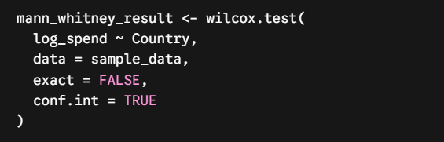
In addition, a non-parametric robustness check was performed under the assumption that the conclusions were not simply due to a "log transformation" or residual non-normality, by applying the Mann-Whitney U test (wilcox.test). The Mann-Whitney U-value test compares the mean ranks of the data sets rather than the raw means of the continuous data sets making it very robust against extreme values(SURMEN et al., 2026).

Interpretation of Model Outputs and Business Translation
The results of the statistical tests have to be translated back into actionable business metrics.
First, we discuss the Welch t-statistic, its degrees of freedom, and p-value that come from it. If the p-value is below our accepted level of alpha significance of 0.05, we have enough evidence to reject the Null Hypothesis (H0). This suggests that there is a significant difference between the actual mean amount customers spent in the United Kingdom and Germany. The upper and lower limits of this true difference are given by the outputted 95% confidence interval.

This difference is explained in the Cohen's d output. The value close to 0.2 means a small effect, between 0.5 and 0.8 means a medium effect and 0.8 or above means a large, noticeable difference in the behaviour of expenditure between the two groups.

The business stakeholder does not have the raw group means available and these inferential tests were performed on the log (log_spend) scale. For clear presentations, the mathematical mean values of the log-transformed data were back-transformed to some approximation in the original spending scale:
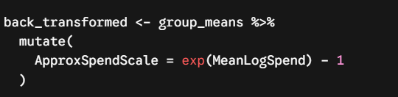
We then extracted the individual methods for the UK and Germany to compute the MSR:
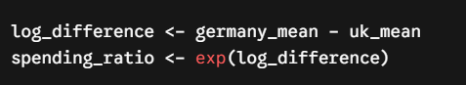
The spending_ratio is a very powerful Business Metric. For instance, if the ratio they calculate is 1.30, they can be confident in telling management that the average German spends around 30% more per lifetime with the company than the average UK.

OUTPUT ANALYSIS (GRAPHS & CHARTS)
Figure 1 (Boxplot of transaction revenue): Shows the raw values of the orders being highly positively skewed with many transactions being close to zero but some transactions are very large, at up to £170,000. This makes it necessary to transform data (Ang, Morris and Savi, 2022).
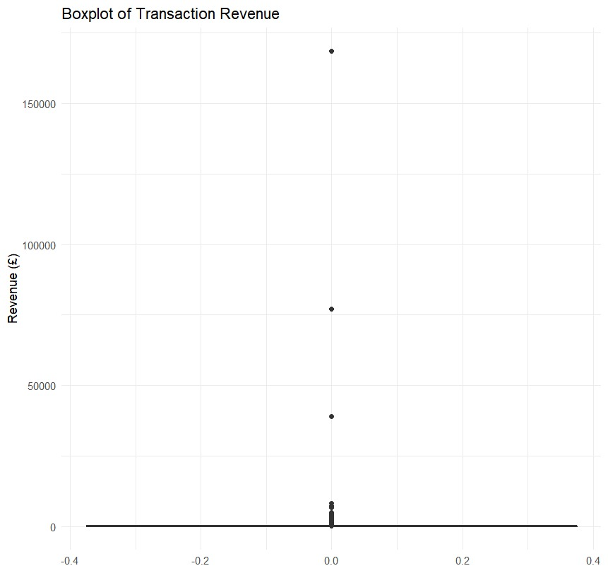
Figure 1Boxplot

Figure 2: Top 10 Countries by Revenue (Top 10 Countries by Gross Revenue) shows that the UK is the source of most gross revenue (£7M+), with Germany, the Netherlands and France the main gross export destinations.
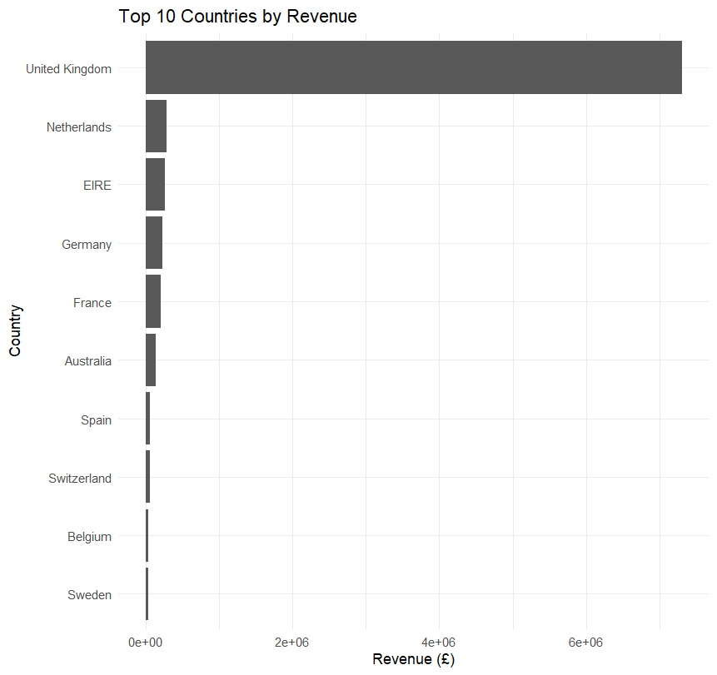
Figure 2 Top 10 Countries by Revenue

Figure 3 (Number of Customers: UK vs Germany): A very large sample size difference (almost 4000 vs approximately 100) makes it valid to use stratified sampling and perform a Welch's t-test as opposed to a standard equal-variance test.
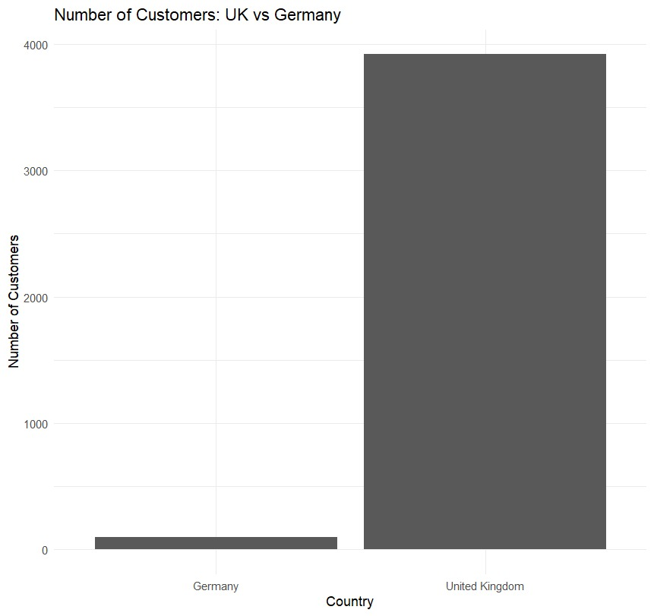
Figure 3 Number of Customers: UK vs Germany

Figure 4 (Customer Spending: UK vs Germany - Raw): Shows that raw spend is heavily skewed to the right with extreme outliers in both markets, which renders it non-normal.
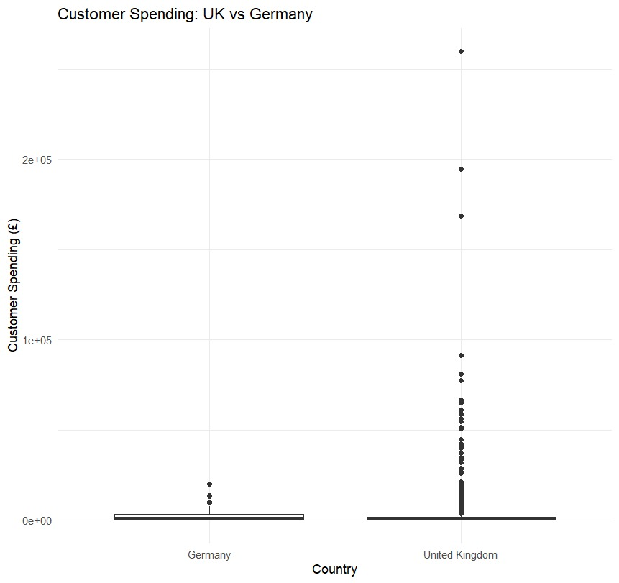
Figure 4 Customer Spending: UK vs Germany

Figure 5 (Distribution of Log Customer Spending): After applying a log(x + 1) transformation, the customer spend data is successfully normalized to a bell-shaped distribution that is symmetrical, and suitable for parametric testing.
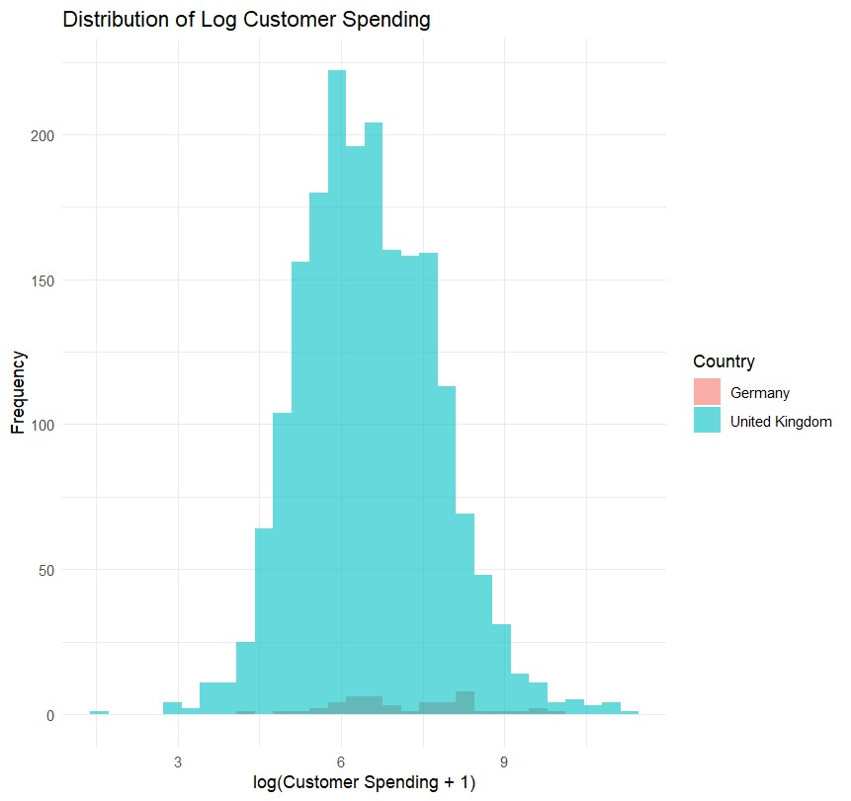
Figure 5 Distribution of Log Customer Spending

Figure 6: Log Customer Spending by Country: Indicates that the median log spends and the overall interquartile range of the German customers is higher than the UK customers.
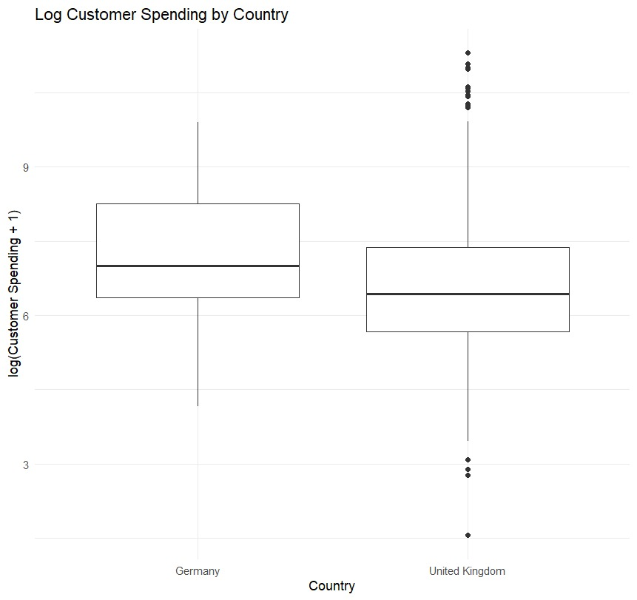
Figure 6 Log Customer Spending by Country

Figure 7 (Q-Q Plots of Log Customer Spending): Supports the normality assumption, with data points closely aligning with the theoretical normal line, with some minor deviations at the tails(Shatz, 2023).
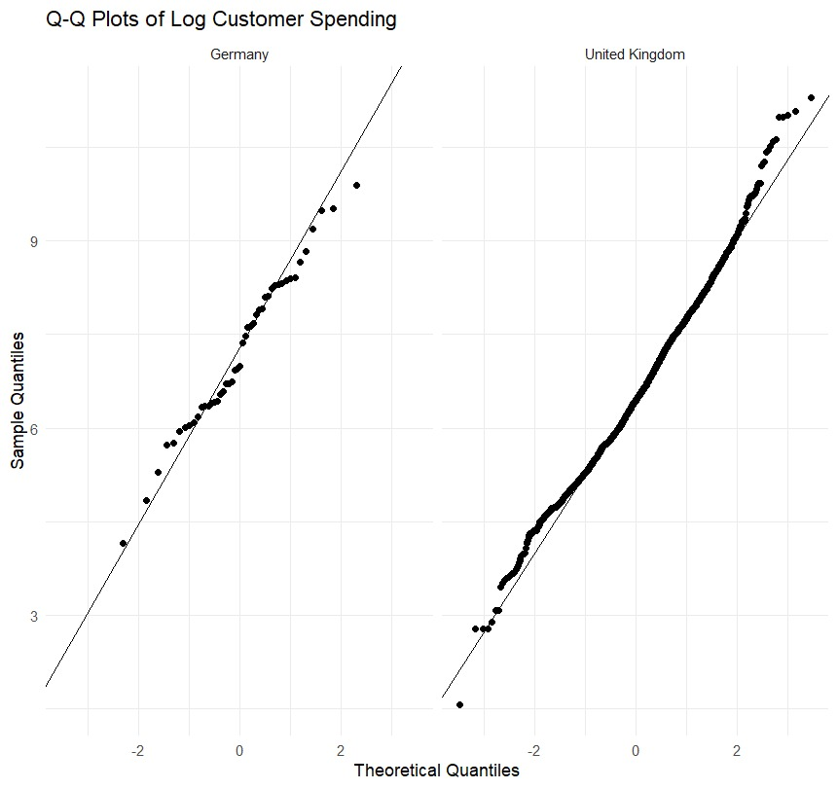
Figure 7 Q-Q Plots of Log Customer Spending

Figure 8 (Top 10 Products by Revenue): Identifies top-earning inventory items, such as "PAPER CRAFT , LITTLE BIRDIE" and "REGENCY CAKESTAND" and also top revenue postages which can be realised through local European fulfillment.
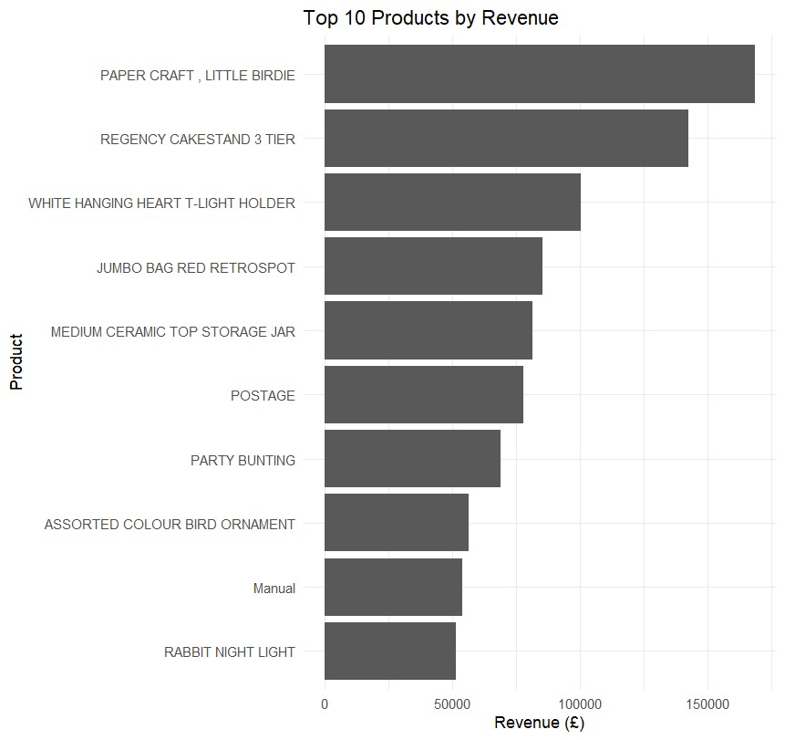
Figure 8 Top 10 Products by Revenue

Conclusion & Limitations of Analysis
The aim of this applied statistical modelling project was to produce empirical evidence to inform strategic decision making. The data proved to be a good proof of the effectiveness of geographical segmentation as a powerful predictor of customer spending behaviour.

In what ways is it that different?
A significantly higher spend per sale for German customers indicates structural differences in eCommerce spend. The usual trade-offs of cross-border purchasing are shipping costs, delivery time and customs delays. This rubbing action naturally excludes buyers who may buy just one low dollar item, the “casual” buyers. Accordingly, most of the international customers who are willing to have to pay these costs are wholesale customers or B2B customers buying in bulk. By contrast, the domestic UK market has a vast amount of what is known as incidental low-value retail sales.
From this analysis, the next steps to address the initial business problem of optimizing business costs and marketing spending are as follows:
Immediate digital marketing budget changes are needed, as Tiered Customer Acquisition Cost (CAC) Allocation requires review. The German market may have a much higher average lifetime value per customer and the business may be able to afford more money to be spent on acquiring a German lead. In Europe, the emphasis needs to be shifted towards specific B2B marketing (for instance, LinkedIn or industry-specific trade networks) and away from general consumer marketing on social media, in which the value is high.
The UK market is smaller on average due to the implementation of Domestic Threshold Incentives: the company must drive up basket size in the UK market. This can be done via "Minimum Spend for Free Shipping" levels (e.g. Free Shipping on spend of £50 or more) or via tiered volume discounts. This way, lower value retail customers are encouraged to put another item in their basket, increasing overall mean spends per customer without losing its core customers.
The top 10 products by gross revenue were identified for the EDA section of this report, which is related to the logistics and inventory pre-positioning. These high velocity Stock Codes should be checked against information regarding orders from Europe by the supply chain team. Supporting these top 10 items in third party logistics (3PL) warehouses in Germany or mainland Europe would significantly mitigate cross-border shipping friction and further accelerate the growth of this very profitable cross-border market segment.
The approach to the statistical analysis that has been used is sound and soundly tested, but responsible data science would be incomplete without any appreciation of limitations of the analysis.
Temporal Snapshot Limitation: This data set contains transaction information from a point in time. These observed customer spending patterns might be substantially influenced by a particular macro-economic situation, unobserved promotion activities, or a particular seasonality of the holidays that may have been experienced only during the period of data collection. The ratios of these expenditures are not stable into the future and should not be assumed to be the same.
Omitted Variable Bias: Dataset is not sufficiently “rich”. We have geographical data, but we do not have a wealth of demographic or firmographic data (categorization of the customer, its age, income, etc. or even a clearer distinction between B2C and B2B). This means that, although the statistics show that Germany customers spend more, it is not possible to conclude from this data alone why this is the case.
Lost Granular Variance: When we calculate thousands of individual transaction rows and sum them up to create a single summary of what each customer has purchased over time, we have lost the ability to see buying frequency over time at the individual transaction level.

GitHub Repository Declaration
All R scripts, empirical experiments and documented implementations used in this analysis are kept in a version-controlled repository as per assessment guidelines. After the submission date, no changes will be accepted in the repository to protect academic integrity.
Repository Link:

References
Arel-Bundock, V., Greifer, N. and Heiss, A. (2024). How to interpret statistical models using marginaleffects for R and python. Journal of Statistical Software, [online] 111(9). doi:10.18637/jss.v111.i09.
Narra, B., Gupta, A., Polu, A.R., Vattikonda, N., Buddula, D.V.K.R. and Patchipulusu, H. (2025). Predictive analytics in e-commerce: Effective business analysis through machine learning. SSRN Electronic Journal. doi:10.2139/ssrn.5315532.
Ali, N. and Shabn, O.S. (2024). Customer lifetime value (CLV) insights for strategic marketing success and its impact on organizational financial performance. Cogent business & management, 11(1). doi:https://doi.org/10.1080/23311975.2024.2361321.
Raymond Yang Gao (2023). A battle of the big three?—Competing conceptualizations of personal data shaping transnational data flows. Chinese journal of international law, 22(4), pp.707–787. doi:10.1093/chinesejil/jmad040.
Katyal, A., Sharma, P.K. and Kannan, M. (2025). Exploratory data analysis (EDA) on undergraduate data science students through R programming. doi:10.21203/rs.3.rs-7422204/v1.
Alabi, O. and Bukola, T. (2023). Introduction to descriptive statistics. [online] www.intechopen.com. Available at: https://www.intechopen.com/chapters/1141192 [Accessed 18 Sept. 2026].
Casella, G. and Berger, R. (n.d.). Statistical inference. [online] Google Books. Available at: https://books.google.com/books/about/Statistical_Inference.html?id=LhgFEQAAQBAJ [Accessed 18 Sept. 2026].
Emmert-Streib, F. (2024). Trends in null hypothesis significance testing: Still going strong. Heliyon, 10(21), p.e40133. doi:10.1016/j.heliyon.2024.e40133.
Aven, T. (2023). When to dismiss an alternative hypothesis or theory? A risk and uncertainty perspective. Journal of Risk Research, 26(12), pp.1396–1407. doi:10.1080/13669877.2023.2288011.
de Winter, J. (2026). Neither the T-test nor Welch’s test: A case for robust alternatives in two-sample comparisons with non-ideal data. Quality & Quantity. doi:10.1007/s11135-026-02909-5.
SURMEN, M.Y., Oya KILCI, BAHAR, S.S. and Murat KOKLU (2026). Data-driven prediction of processing times and delays across supply chain operational stages using machine learning. Intelligent Methods In Engineering Sciences, [online] 5(2), pp.69–82. doi:10.58190/imiens.2026.176.
Zhang, Y.-P., Zhang, X.-Y., Cheng, Y.-T., Li, B., Teng, X.-Z., Zhang, J., Lam, S., Zhou, T., Ma, Z.-R., Sheng, J.-B., Tam, V.C.W., Lee, S.W.Y., Ge, H. and Cai, J. (2023). Artificial intelligence-driven radiomics study in cancer: The role of feature engineering and modeling. Military Medical Research, 10(1). doi:10.1186/s40779-023-00458-8.
Bailey, N.W., Biabani, M., Hill, A.T., Miljevic, A., Rogasch, N.C., McQueen, B., Murphy, O.W. and Fitzgerald, P.B. (2023). Introducing RELAX: An automated pre-processing pipeline for cleaning EEG data - part 1: Algorithm and application to oscillations. Clinical Neurophysiology, [online] 149, pp.178–201. doi:10.1016/j.clinph.2023.01.017.
Ang, A., Morris, T. and Savi, R. (2022). Asset allocation with Crypto: Application of preferences for positive skewness. [online] papers.ssrn.com. Available at: https://papers.ssrn.com/sol3/papers.cfm?abstract_id=4042239 [Accessed 18 Sept. 2026].
Shatz, I. (2023). Assumption-checking rather than (just) testing: The importance of visualization and effect size in statistical diagnostics. Behavior Research Methods, 56(2). doi:10.3758/s13428-023-02072-x.
Jiang, R., Li, P. and Zhang, K. (2024). Quantile-quantile plot of folded-normal distribution and its applications in reliability and quality modeling. 2024 10th International Symposium on System Security, Safety, and Reliability (ISSSR), [online] pp.44–50. doi:10.1109/isssr61934.2024.00011.
Fiel Peres, F. (2026). Effect sizes for nonparametric tests. Biochemia medica, [online] 36(1), pp.5–16. doi:10.11613/bm.2026.010101.
Samara, M. Al, Bennis, I., Abouaissa, A. and Lorenz, P. (2022). A survey of outlier detection techniques in IoT: Review and classification. Journal of Sensor and Actuator Networks, 11(1), p.4. doi:10.3390/jsan11010004.

